PRR & VS Government College
Vidavalur, SPSR Nellore District
(Accredited by NAAC with ‘B⁺’ Grade)

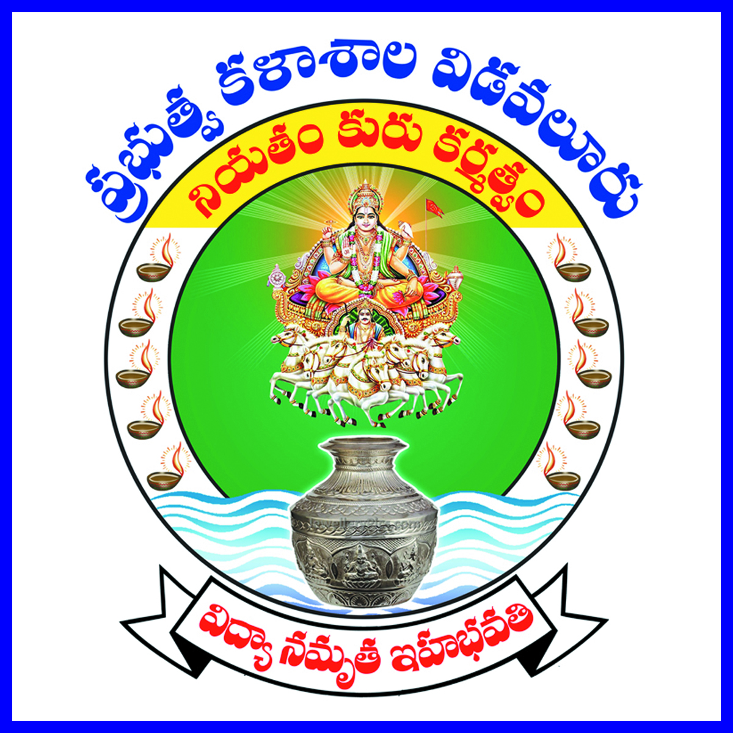

59th College Day Celebrations
16th April 2024

College Annual Report
2023-24

Principal: Dr. B. Sujatha, M.Sc., Ph.D.
Teaching Staff:
S. No | Name of the Staff
1 | Dr. N. Madhu | Lecturer in Physics & Vice Principal
2 | Dr. V. Sri Rama Murthy | Lecturer in English
3 | Dr. G. Padma Priya | Lecturer in Telugu
4 | Dr. D. Eswara Rao | Lecturer in Mathematics
5 | Sri Sk. Nyamathulla | Lecturer in Physics
6 | Dr. E. V. Suresh Kumar | Lecturer in Chemistry
7 | Dr. R. Srinivasa Rao | Lecturer in Chemistry
8 | Dr. G. Varalakshmi | Reader in Statistics
9 | Sri K. Ravinchandra Reddy | Lecturer in Botany
10 | Sri P. Sudhakar | Lecturer in Botany
11 | Dr. I.S. Chakrapani | Lecturer in Zoology
12 | Dr. K. R. Shanmugam | Lecturer in Zoology
13 | Mr. M. V. Ramana Rao | Lecturer in History
14 | Dr. A. Venkata Prasad | Lecturer in Economics
15 | Smt. P. Priyanka | Lecturer in Political Science
16 | Sri S. C. Srinivasulu | Lecturer in Commerce
17 | Sri A. Babu Rao | Lecturer in Commerce
18 | Smt. B. Vidyullatha | Lecturer in Computer Science
19 | Smt. V. Sarvani | Lecturer in Computer Applications
20 | Dr. E. Kiran Kumar | Lecturer in Library Science

Non – Teaching Staff:
S. No | Name
1 | Sri J. Penchala Babu, Senior Assistant
2 | Sri P. Venkateswarlu, Junior Assistant
3 | Sri V. V.Subrahmanyam, Storekeeper
4 | Sri C. Penchalaiah, Storekeeper
5 | Sri B. Venkateswarlu, Machanic
6 | Sri P. Rajendra Prasad, Record Assistant
7 | Sri K Srinivasulu, Record Assistant
8 | Sri V Satyanarayana, Record Assistant
9 | Sri SK. Rabbani, Record Assistant
10 | Sri D. Masthanaiah, Attender
11 | Sri T. Madhusudhan Rao, Attender
12 | Sri G. Sumanth Reddy, Attender
13 | Smt. A. Madhuri, Attender
14 | Sri G.Narayana, Sweeper

PRR & VS Government College, Vidavalur, SPSR Nellore District
(Accredited by NAAC with ‘B+’ Grade)

Respected guests of today,
Chief Guest:
Sri B. D. Deena Dayal, Principal, Government Junior College, Vidavalur, who constantly supports us in strengthening our institution,

Guests of Honour:
- Sri M. Raja, Sub Inspector of Police, Vidavalur, who helps our college from time to time in maintenance of discipline,

- Sri P. Sriharsha, Manager, Canara Bank, Vidavalur, who helps our institution in banking services,

I have immense pleasure in welcoming you all to the 59th College Annual Day Celebrations in our college. It is my duty and privilege to present the annual report of the college that includes all the activities and achievements during the academic year 2023-24.

Brief History of the Institution:
PRR&VS Government College, Vidavalur was started as a composite co-education college on 8th July, 1965. The donors were Sri Ponnaluru Ramachandra Reddy and Smt. Venkata Subbamma, landlords of Vidavalur. The college has 11.72 acres of campus. The college got its recognition under 2(f) and 12(b) of the UGC, in the year 1991. The college was affiliated to Sri Venkateswara University right from its inception i.e., from 1965-66 to 2009-10. From 2010-11 onwards, the college has been affiliated to Vikrama Simhapuri University, Nellore. The college was re-accredited in 2023 with ‘B⁺’ grade with CGPA score of 2.58.
At present our college strength is 218. They include 135 boys and 83 girls. The teaching staff members are 20. There are 14 members of the non-teaching staff. In our college, we offered the courses B.Sc. (MPCs, MSCs, BZC), BA (HEP) and B.Com. (CA) till last year. According to the National Educational Policy – 2020, Single Major Course system has been introduced. Hence, from the Academic Year 2023-24 onwards we offer the courses BSc (Mathematics, Physics, Zoology), BA (History) and B.Com. (CA).

Special Occasions:
In addition to the celebration of the national festivals like Independence Day, Republic Day, we also celebrated various important days like International Yoga Day, International Drug Day, International Youth Day, Mathrubasha Dinoshanam, Indian Constitution Day, World AIDS Day, National Human Rights Day, World Food Day, National Youth Day, National Voters’ Day, and International Women’s’ Day.

Extension Activities:
Several guest lecturers have been organized by various departments of our college. Our lecturers were invited by various other colleges to deliver their lecturers in their respective fields.
NSS Activities:
Initially Dr. A. V. Prasad, Lecturer in Economics and at present Mr. P. Sudhakar, Lecturer in Botany , NSS Programme officer conducted NSS Clean and Green activities. The students were advised to participate in various social welfare activities. Clean and green activities were done on the college campus. Our student, Ms. Bhavana, III BA (HEP) participated in the NSS adventure camp and got special recognition.

NCC Activities: Our college has an NCC Naval unit. Mr. Sk. Nyamathulla, Lecturer in Physics is the NCC Officer. He is actively looking after the NCC activities in the college. Our student, Ms. Vishnupriya, III BA (HEP) participated in the Naval camp and got a special prize.

Red Cross Unit:
All the students of the college were enrolled as volunteers in College Red Cross Unit. Red Cross volunteers participated in Blood Donation Programme on various occasions and donated about 20 Units for Red Cross Nellore.

Physical Education Activities:
Dr. A. V. Prasad, Lecturer in Economics played vital role in monitoring the physical education activities in the absence of the physical director. Our college students participated at district, state university and interuniversity level sports and games tournaments during 2023-24.
Our staff, Dr. E. Kiran Kumar, Lecturer in Library Science and Mr. Sk. Nyamathulla, Lecturer in Physics also participated in the District level Chess competitions and got prizes.
Library:
We have a good library in our college with nearly 16,000 books. Now the library is fully equipped with the latest magazines and has become a rich resource of knowledge for all categories of students and staff to sharpen their minds. The library equipped with NLIST e- Journals along with print journals and library is automated with “SOUL” software and work is in progress.
Jawahar Knowledge Centre (JKC):
The College has a Jawahar Knowledge Centre, which is a platform for training the students in strengthening their employability skills. The students who join JKC are trained in soft skills, communication skills, analytical skills and computer skills to make them competent to face the challenges in the job market. The JKC trained students got placements and admissions into higher education courses. This year a Job drive was conducted in our college inviting Hero Motor Corps and Neo Lync Setup Box Companies. Our students attended a job drive conducted at NRC level in Nellore. Out of 70 Students participated, 38 Students were selected.

Research:
I am very glad to express that Twelve members of teaching staff in our institution are Ph.D. degree holders out of which three are recognized as Research Supervisors to guide Ph.D. scholars. Dr. V. Sri Rama Murthy, Lecturer in English, Dr. G. Varalakshmi, Lecturer in Statistics, and Dr. G. Padma Priya, Lecturer in Telugu. Dr. I.S. Chakrapani, Lecturer in Zoology and Dr. K.R. Shanmugam, Lecturer in Zoology have also applied for Ph.D. guide-ship and it is under process.
Acknowledgements:
In conclusion, I express my thanks to the Commissioner of Collegiate Education, AP, Vijayawada, The Regional Joint Director of Collegiate Education, Guntur, The District Collector, SPSR Nellore District and the authorities of Social Welfare, BC Welfare and Tribal welfare Departments for their continuous support in all aspects. Our thanks are also due to the authorities of VS University, Nellore. Special thanks to the members of CPDC and Alumni of our college for their continuous support to the College and students. My thanks are due to the Teaching and Non Teaching members of the staff without whose cooperation the running of the college would not be possible. I extend my thanks to media friends for their unending cooperation by giving proper media coverage from time to time.
*
* *

